**Crowdfunding data analysis**

Lucas Ulbrich

With this data we can conclude that a lot of creative projects such as plays and music projects have been funded by crowdfunding. This is possibly an incorrect conclusion as the dataset may only be limited to creative projects, except for some web projects, wearable technology, and food trucks. With the information given, we could say that crowdfunding might be a common approach to acquiring funding for these creative projects rather than seeking more conventional approaches to acquiring funding. If the project one is seeking funding for is a creative one, it might be a good idea to approach crowdfunding. Otherwise more conventional approaches to sourcing funding might have more success.

Another conclusion we can draw from this data is that the ratio in success to total crowdfunding projects in most categories is mostly around 50%. There are some exceptions such as journalism, which all 4 projects had successfully received funding. This is an obvious outlier, as there isn’t enough data on journalism projects to successfully draw a conclusion. With this, we could say that there isn’t any categories of projects which stand out to potential crowdfunders. Even when increasing the scope to viewing sub-categories we still end up with most projects having a similar success to total projects in category ratio at around 50%. Furthermore, there are many more smaller sub-categories that act as outliers with large amounts of success, yet there isn’t enough data to say that these sub-categories will be more successful in future projects. It doesn’t seem to matter what category or sub-category of project one chooses. Success seems to be determined on something else.

The final conclusion I will draw from this data is that the staff pick and spotlight have very little impact on the success of a project. Much like what we have seen with the impact that categories have on success of a project, the success to total number of projects with either the staff pick or spotlight is only just over 50%. Even if projects have both a staff pick and spotlight, the success to total number of projects with both staff pick and spotlight ends up being just over 60%. This isn’t enough to show any correlation between the success of a project and receiving a staff pick or spotlight. It does seem like success stems from either external factors or is just left up to pure chance. As this dataset is limited in this, I can’t make a conclusion on the previous comment.

With all this being said, the dataset does have some limitations as previously mentioned. Firstly, the dataset may be limited in scope to creative projects. It is difficult to tell as we don’t have a proper source for each of the projects. Secondly, the dataset is relatively small meaning that it is tough to draw conclusions on successful categories and sub-categories if they only have a few projects in the dataset. We would need a larger dataset to see if these successful outliers will be successful in the long run, or if they will eventually level out to a success rate of 50% like most of the other categories and sub-categories. Finally, there are many external factors that we can’t see with this dataset. We can’t evaluate which projects have a need or market as all we have on each project is a name and a one sentence blurb. If we had a link to each project, we could evaluate what the successful projects do differently from the unsuccessful projects. These limitations severely limit our ability to come to a conclusion about what makes crowdfunding projects successful.

The outcomes of the staff pick and spotlight would definitely benefit from having their own pivot table and stacked column graphs. This helps visualise how few projects receive these benefits as well as visualise how many of these projects fail.

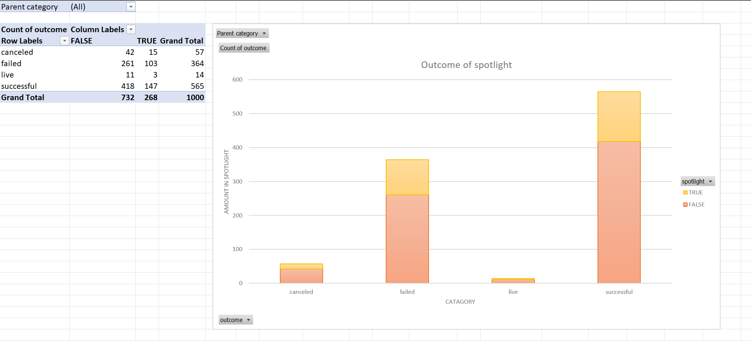

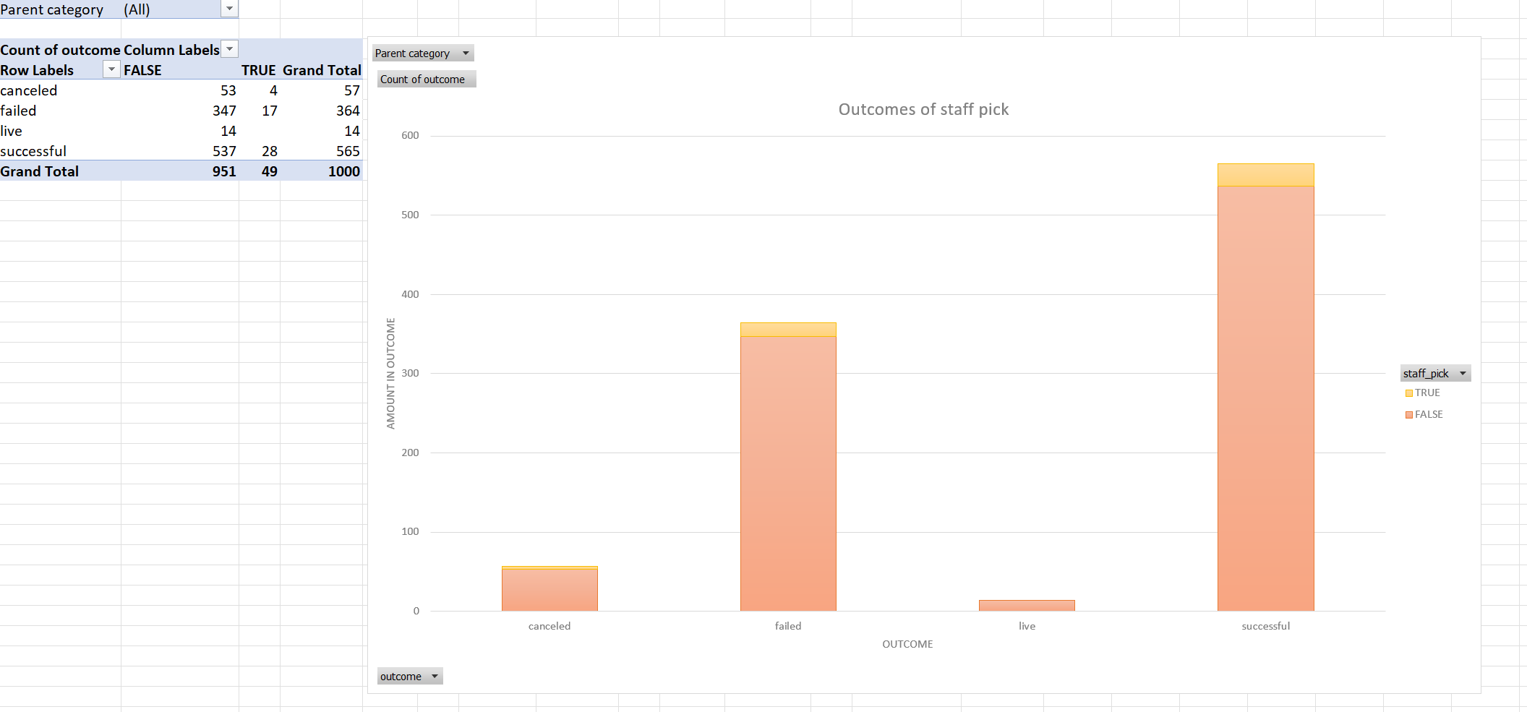

These two fields seemed to be important, yet they were not analysed in the main dataset. With these tables and graphs, we can see that the staff pick and spotlight has very little impact on the success of a project as I have previously stated.